LIBRARY MANAGEMENT SYSTEM
NAME: M. Hema
DEPARTMENT: Computer Science
CLASS: III – BSc Computer Science
PROJECT TITLE: Library Management System (Frontend Only)
Introduction
The Library Management System is a web-based application designed to simplify and organize library activities. It reduces manual work and helps in easy searching and managing of book records using frontend technologies. This System is a web-based application designed to simplify and organize library activities. In traditional systems, library records are maintained manually, which may lead to errors, loss of data, and difficulty in searching book information. This project reduces manual work and improves efficiency by providing a digital method to manage library records.
The system is developed using frontend technologies such as HTML, CSS, and JavaScript. It provides a user-friendly interface that allows users to add, view, and search book details easily. This project helps students understand how web applications work and how frontend technologies are used in real-world applications.

Overview
This project manages library book records digitally. Users can add, view, and search books. Although frontend-only, it can be extended with backend support.
Frontend
The frontend handles user interaction, form validation, and dynamic display of book records using JavaScript.
Frontend Components
a) Book Entry Module
This module allows users to enter book details such as:
- Book ID
- Book Title
- Author Name
- Category / Department
- Availability Status
b) Book Display Module
This module displays all entered book records in a table format, making it easy to view available books.
c) Search Module
This module allows users to search for books using keywords such as title or author name.
d) Navigation Module
This module provides easy navigation between Home, Add Book, and View Book pages.
Technologies Used
HTML – Page structure
CSS – Styling
JavaScript – Validation and dynamic updates
Backend
This project does not include backend implementation. All operations are handled on the client side using JavaScript. However, backend technologies can be integrated in the future to store data permanently and improve security.Working of the System
User opens the application, adds book details, JavaScript validates input, and records are displayed dynamically.
Working of the Frontend
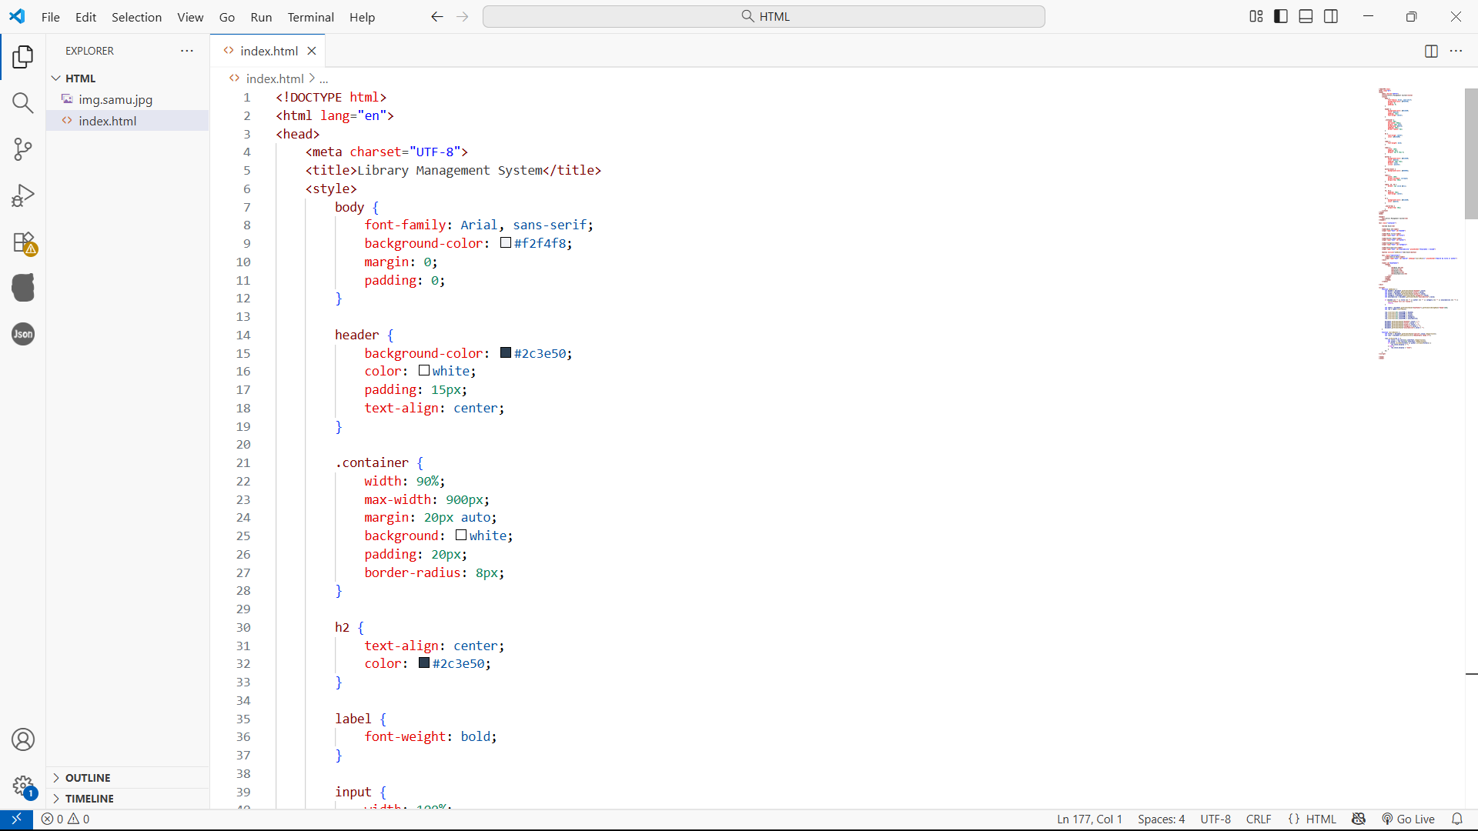
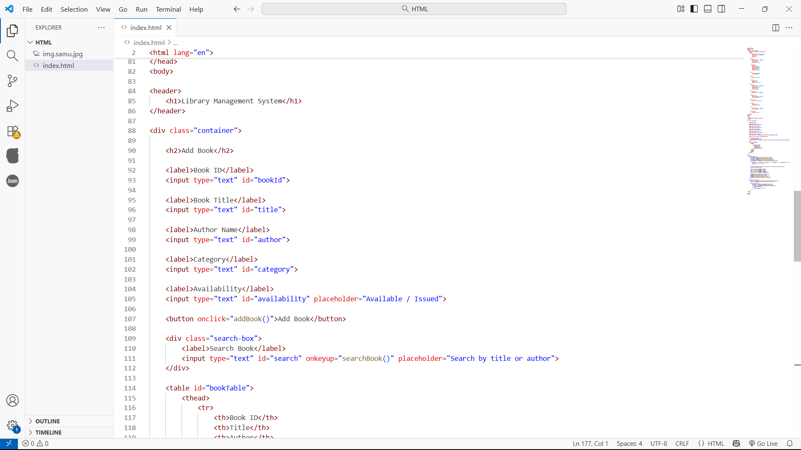
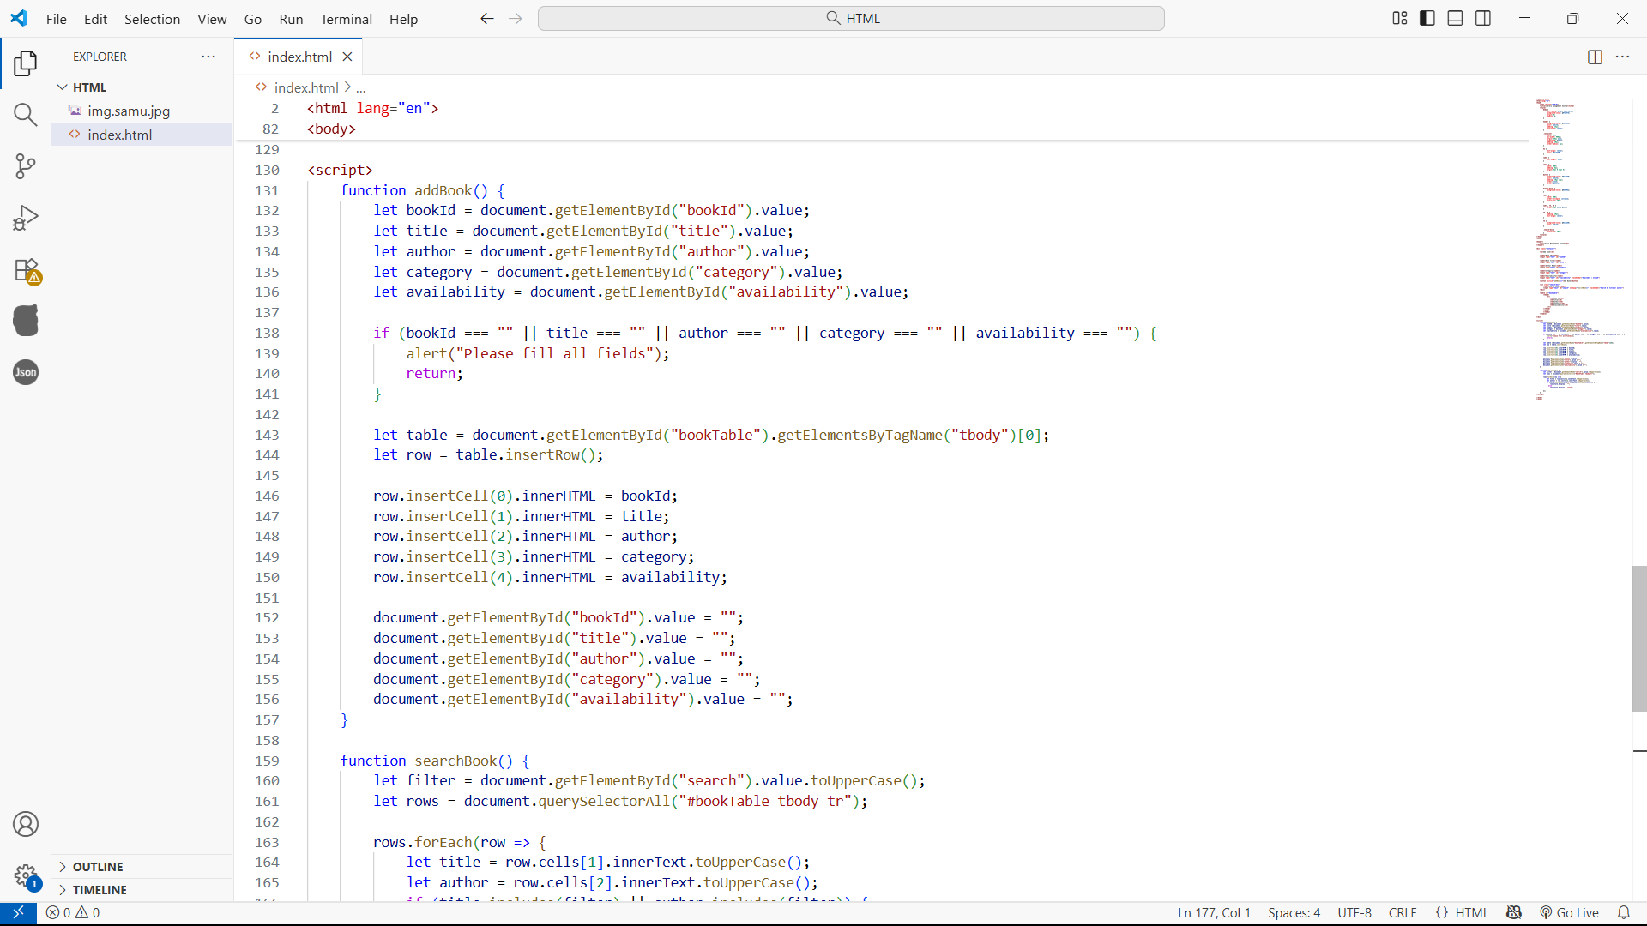
Output
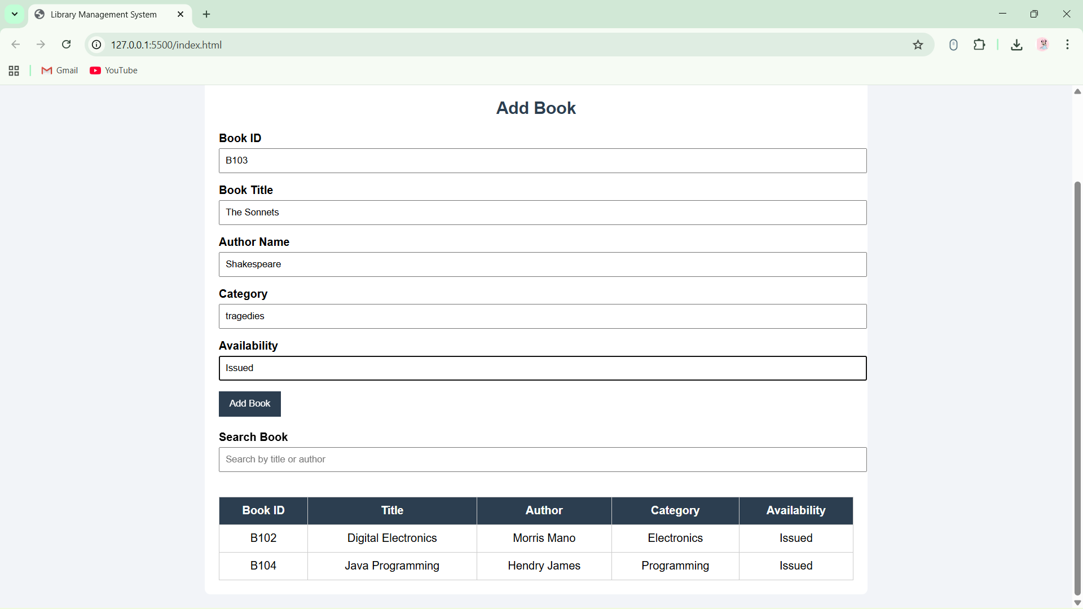
Conclusion
This project demonstrates effective use of frontend technologies to build a simple and user-friendly Library Management System. It provides a strong foundation for web development. This Library Management System project successfully demonstrates the use of frontend web technologies to develop a simple and user-friendly application. It highlights the importance of structured design, data validation, and dynamic content handling. This project provides a strong foundation for understanding web development concepts and can be enhanced further by integrating backend technologies.

